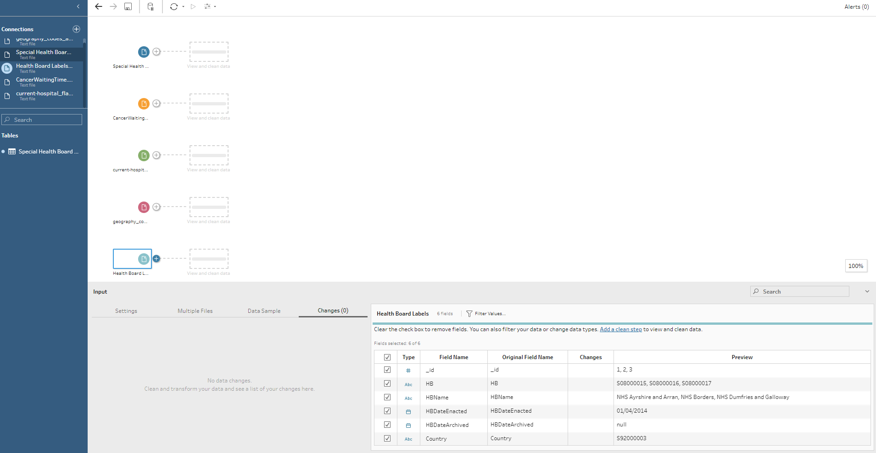

Importing the files into Tableau prep

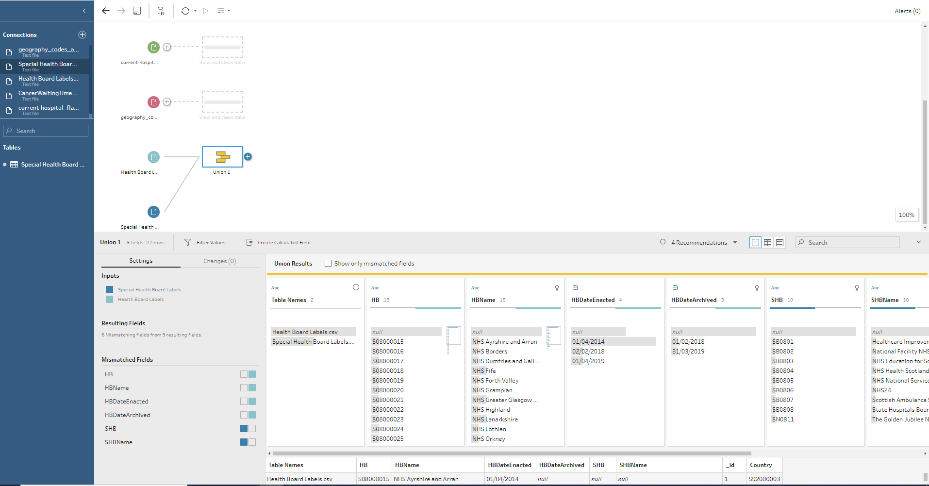

Union of Special Health board labels and Health board label

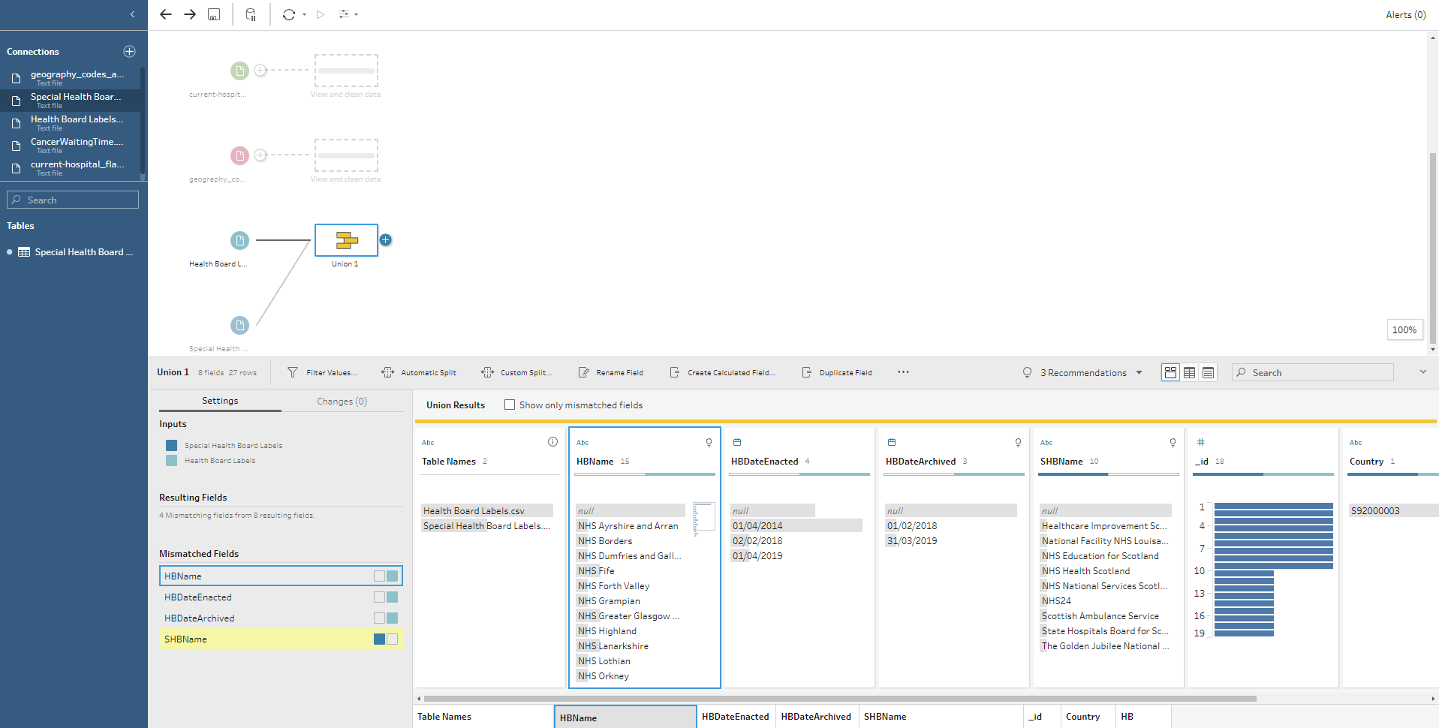

Merging mismatched columns together and deleting the Date columns in the Union

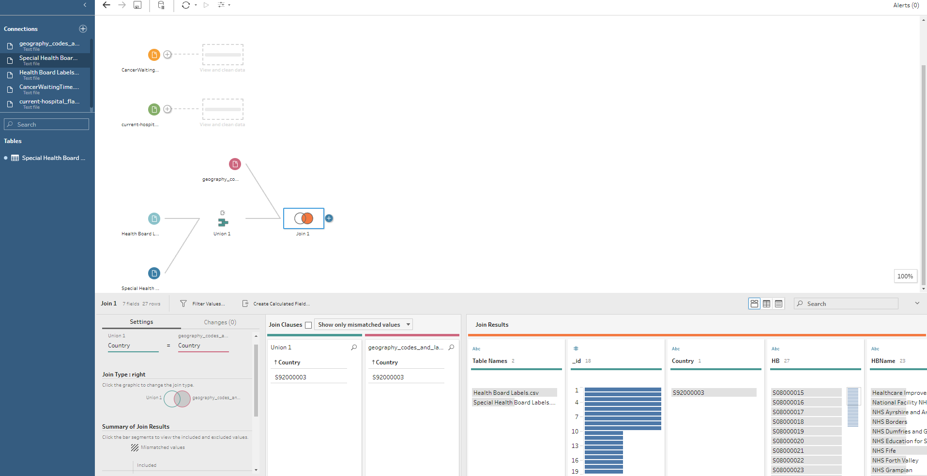

Right Joining the Geographical codes to the Union previously created and cleaning up the country columns

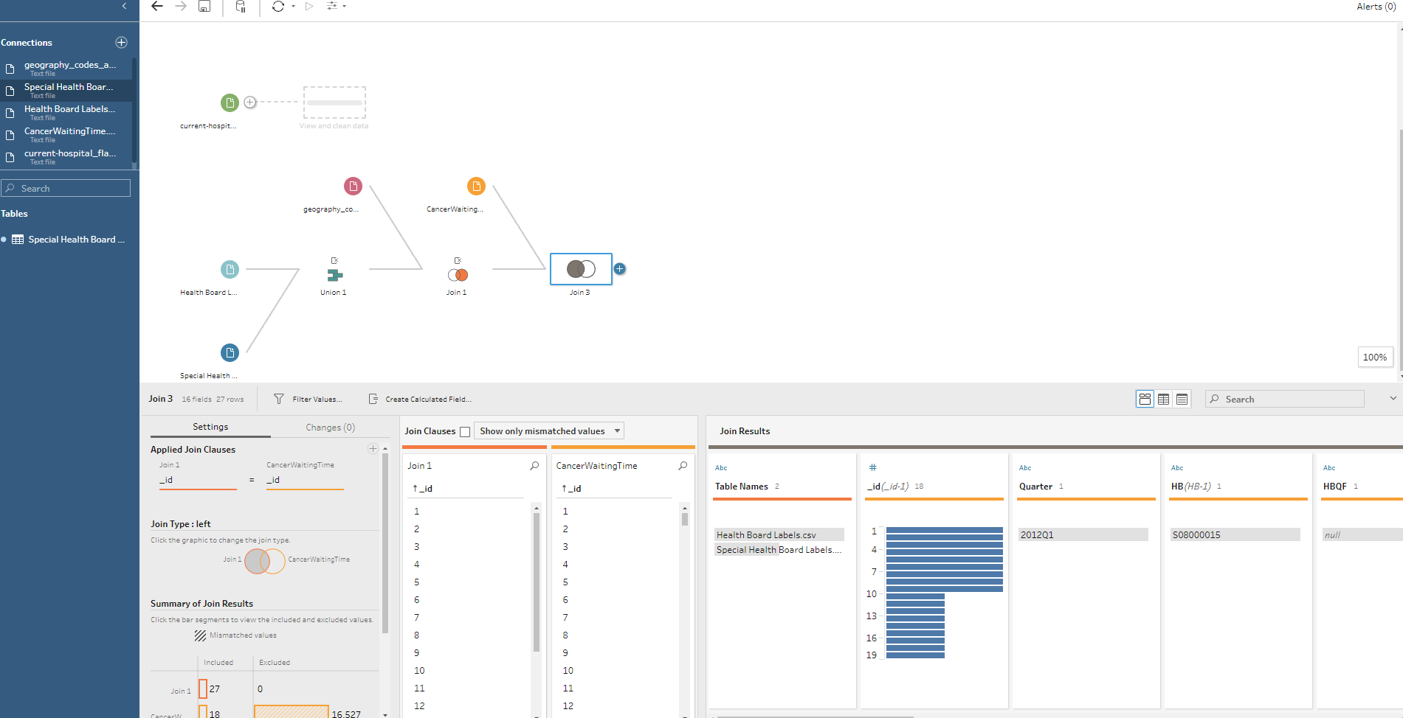

Left Joining our Cancer Waiting time file with the created join and deleting unnecessary QF and HB columns and renaming quarter to date choosing right column format. Changing Country to State and province

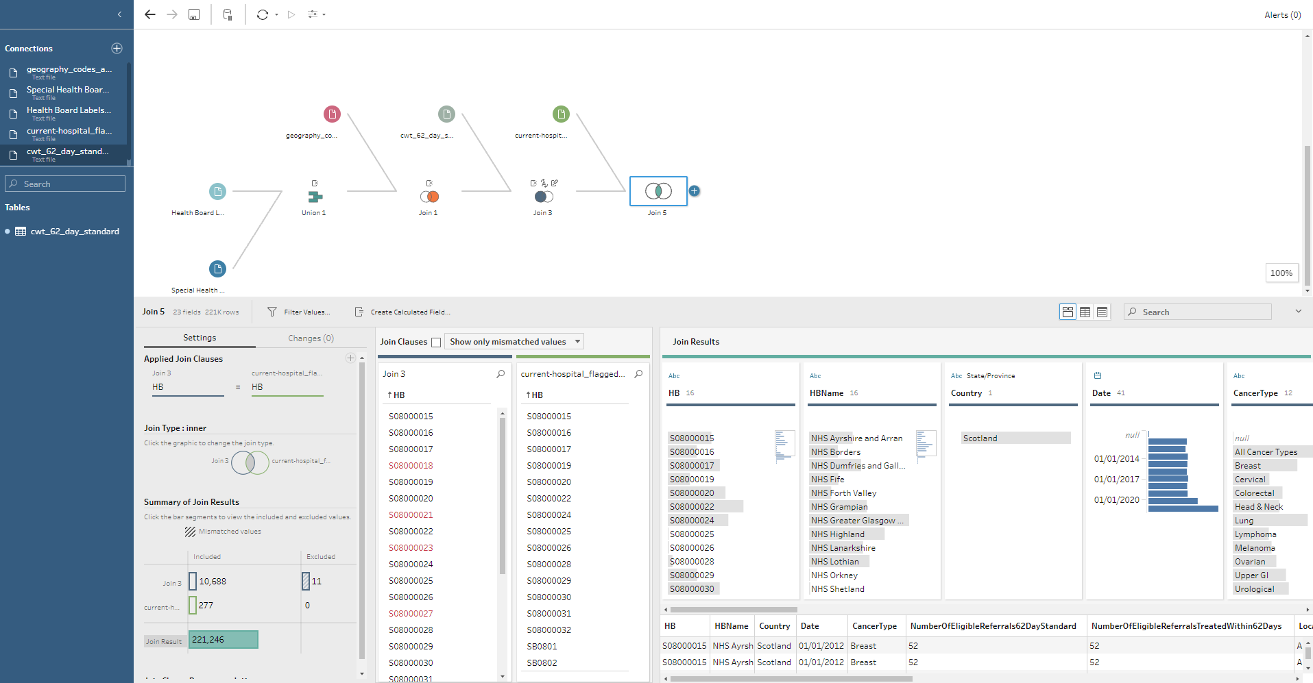

Middle Joining the current hospital flagged file to the created join and removing all unnecessary columns leaving only postcode and location

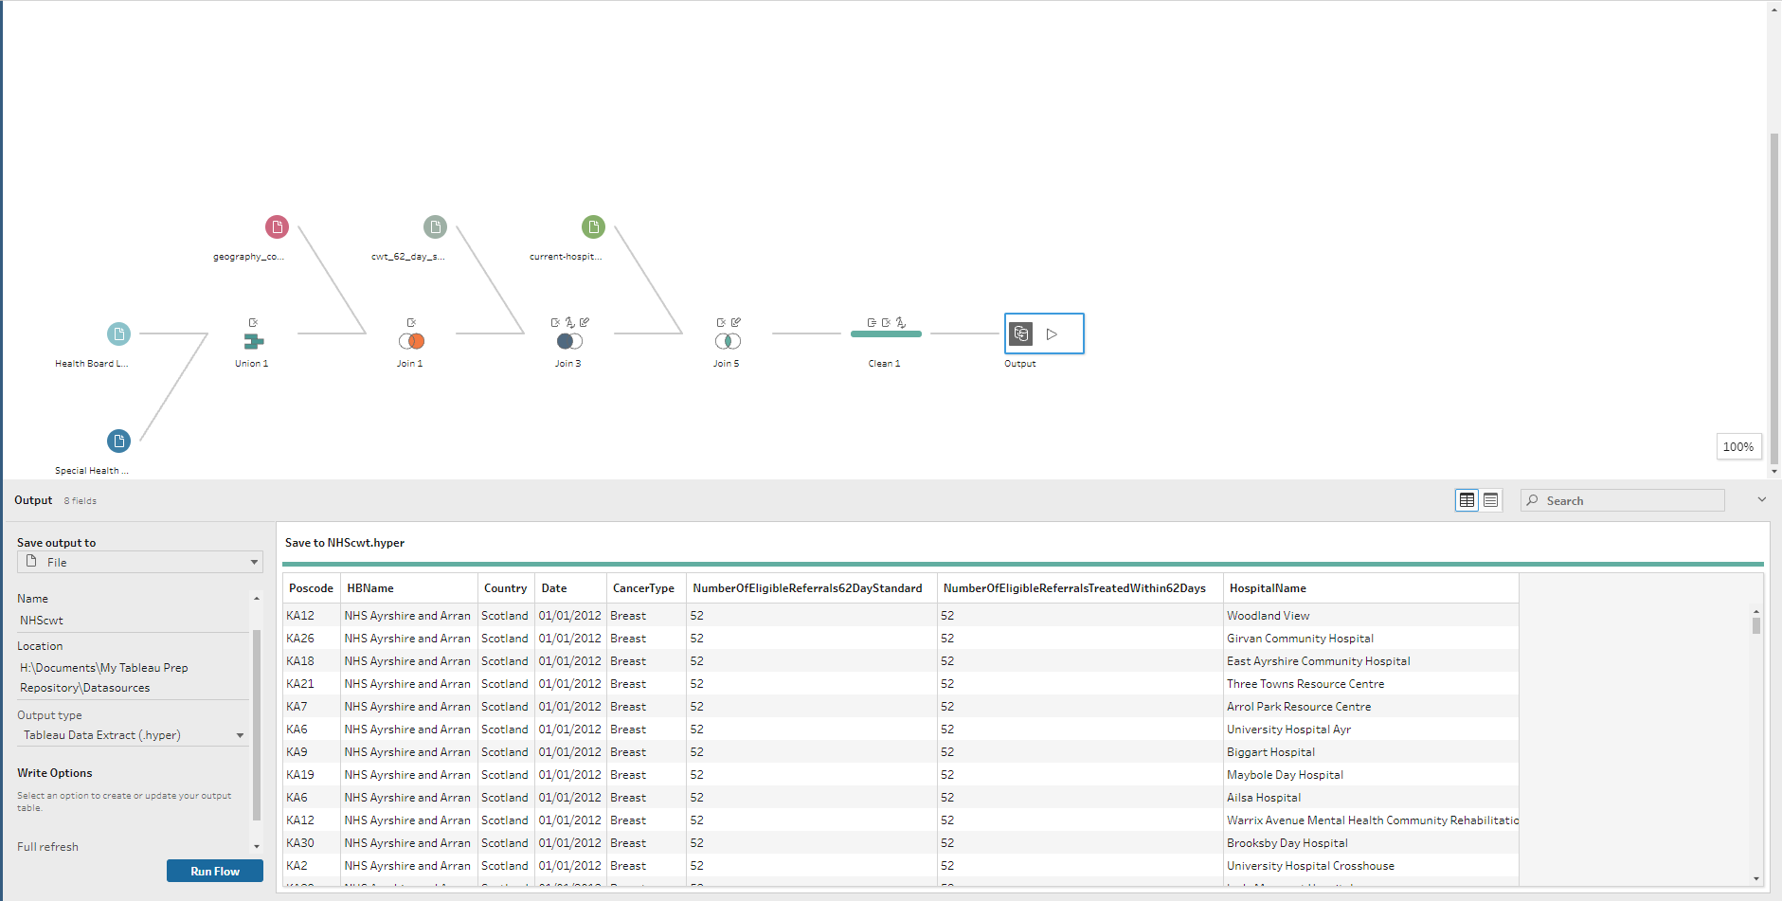

Creating an outputfile for the cleaned data

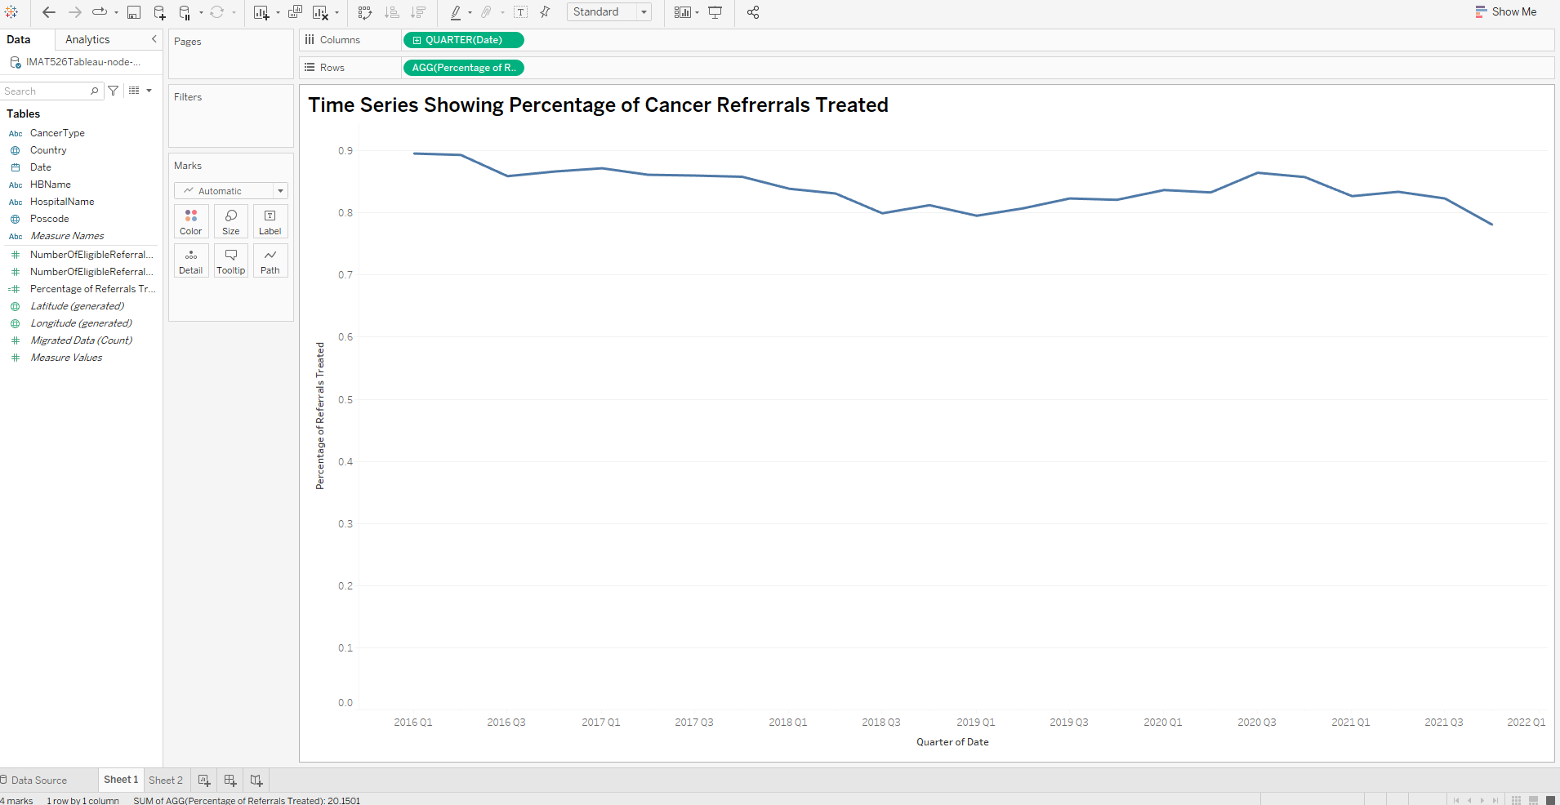

Creating Timeseries for Cancer Waiting time

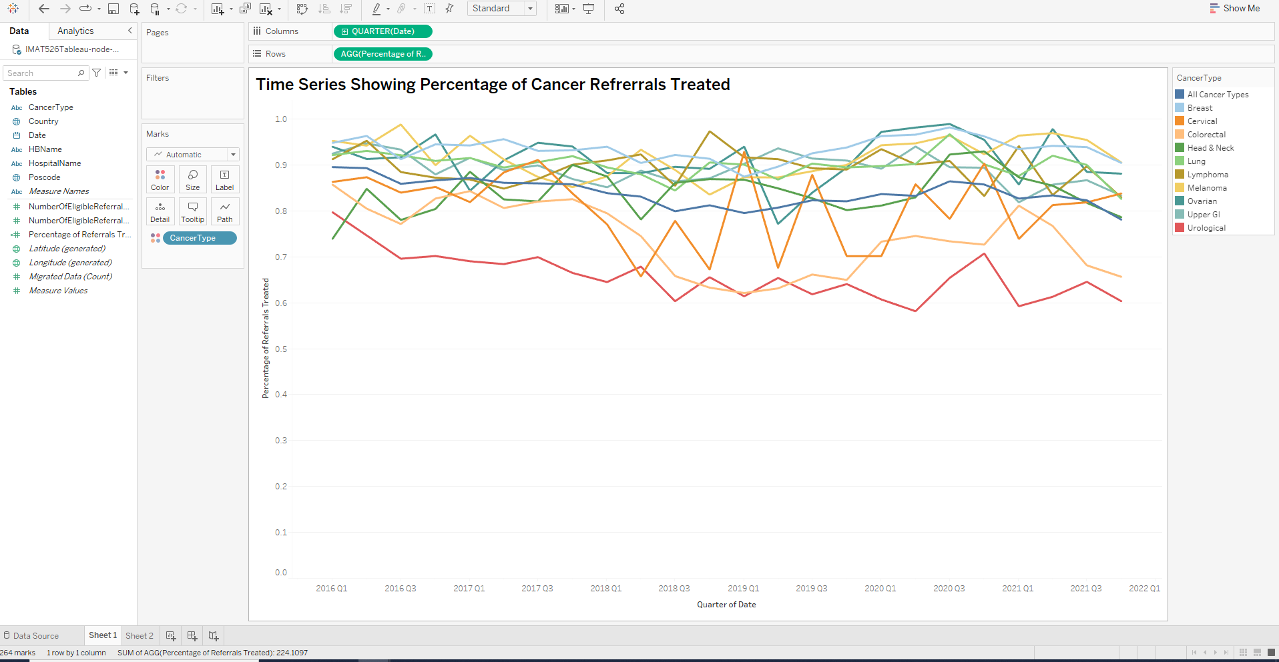

Time series showing % of cancer waiting time per referral

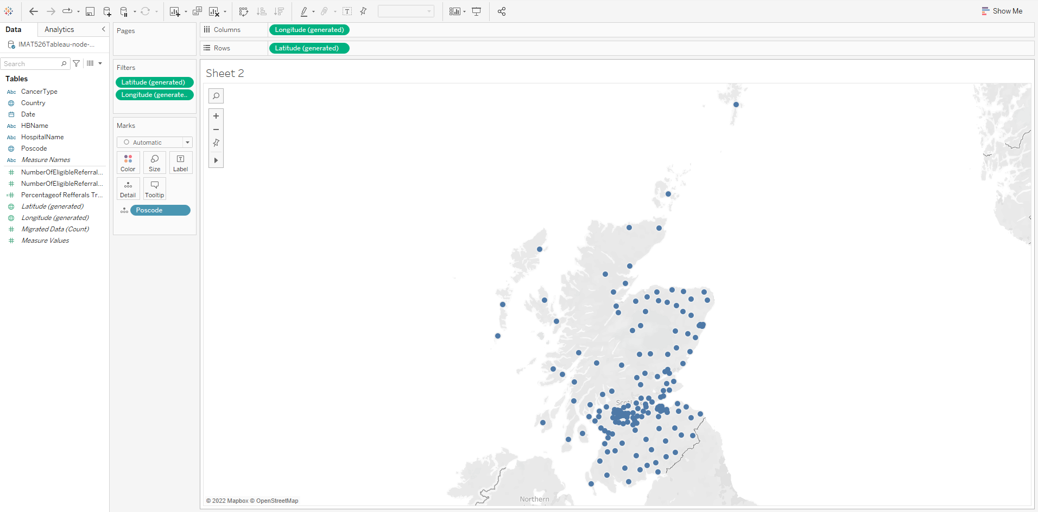

Creating a geographic map

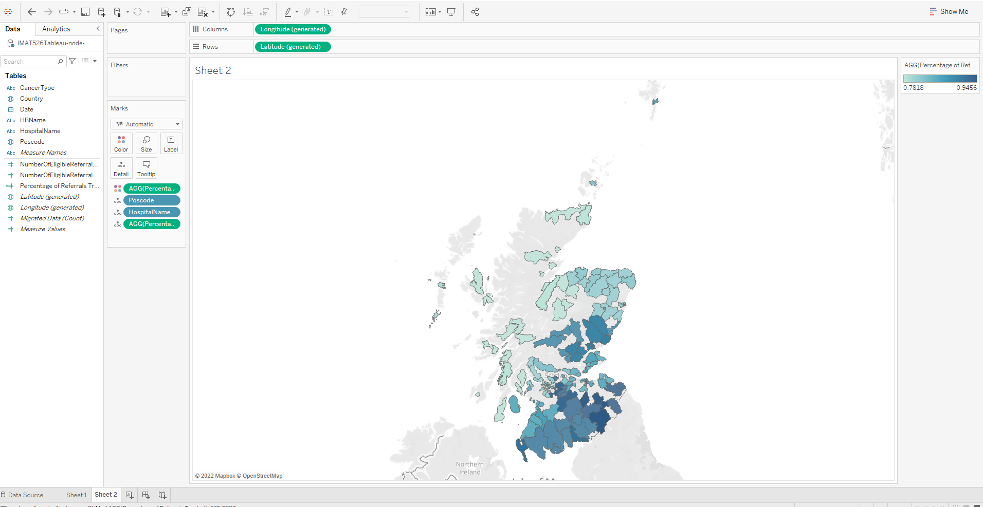

Geographic map showing different hospital locations and their locations

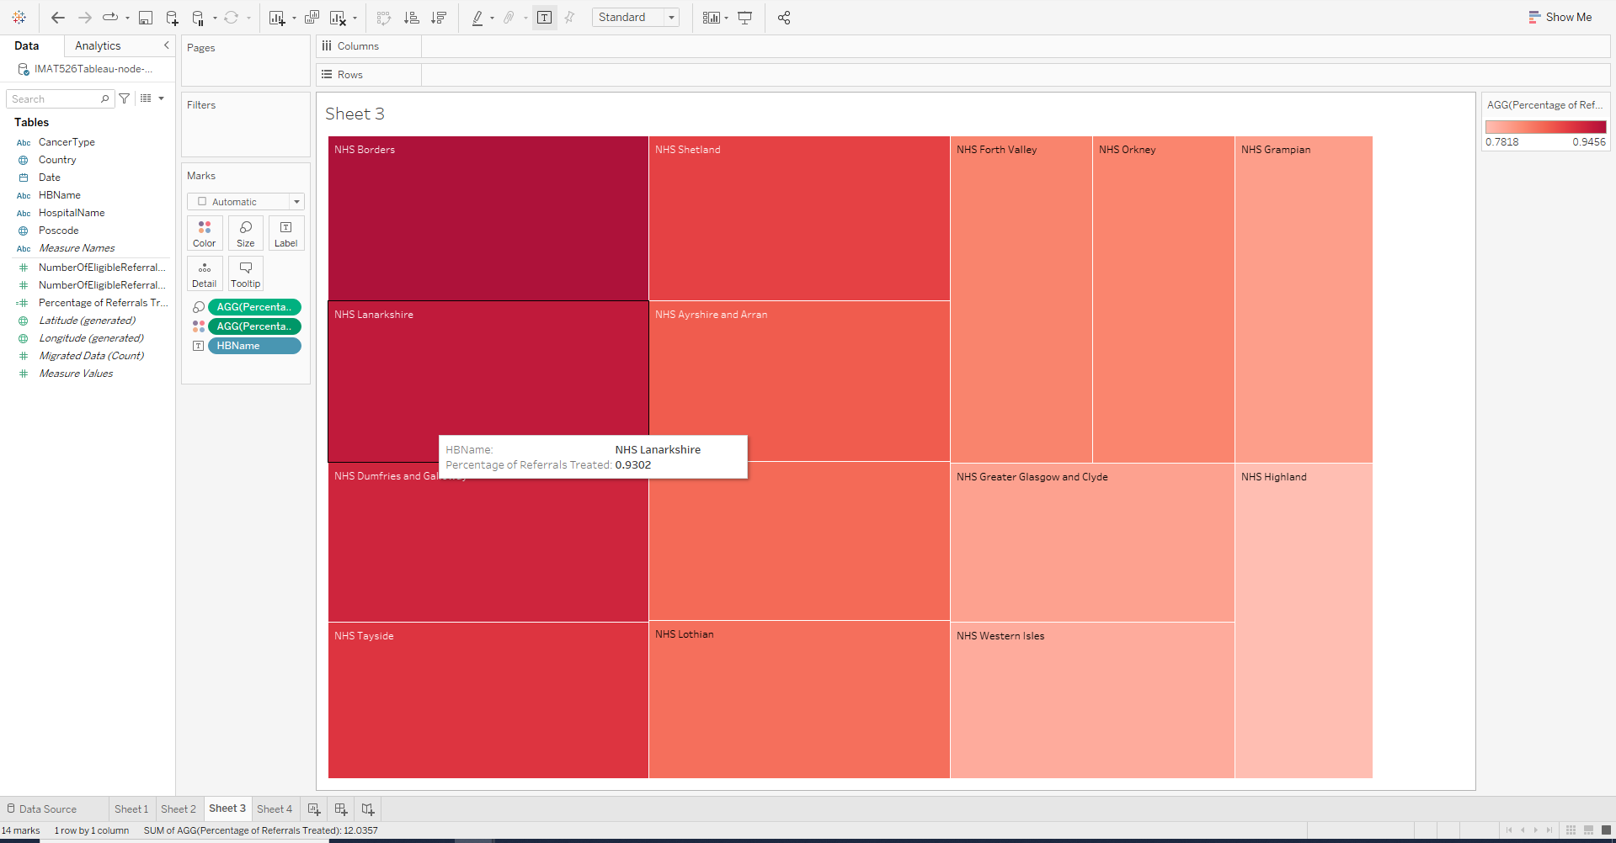

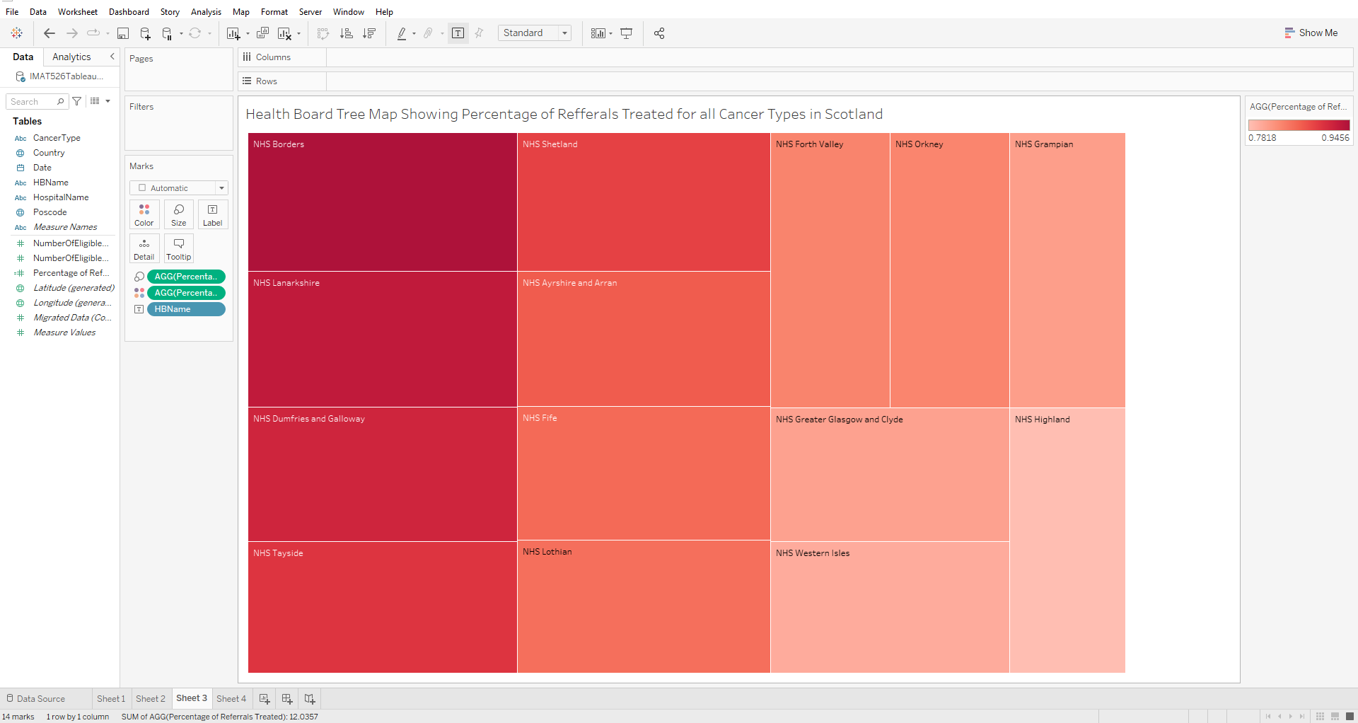

Health Board Tree Map Showing Percentage of Refferals Treated for all Cancer Types in Scotland

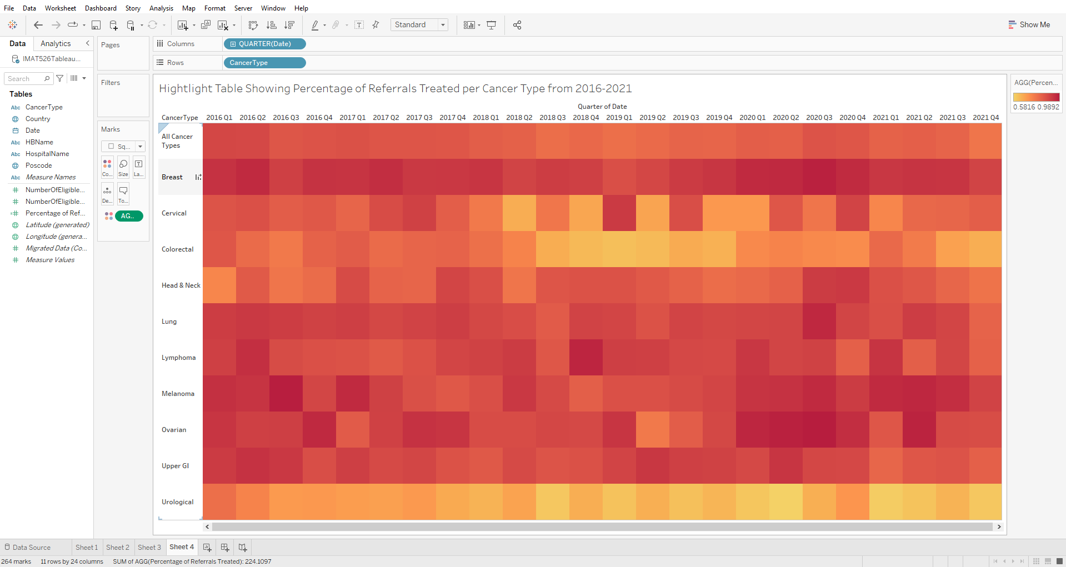

Hightlight Table Showing Percentage of Referrals Treated per Cancer Type from 2016-2021